Switch

Switch

‘Ship 3’

‘Ship 2’

‘Ship 1’

Switch

Power Supply

How is the network used for communication?

The network is designed to use Morse code, which used light signals via the transmitter to represent characters which are then placed together by the receiver in order to decode the message. Our network runs on the scenario of three ships that are unable to communicate as the radios are not working.

The network explained

A messages is sent by an operator who controls a switch, based on the message they will input the message using the protocols defined in the ‘Morse code table’ below. This will then be represent by a light bulb (Notice there are two in the circuit) this is to avoid the message being distorted or in case one of the bulbs was to malfunction. The message is then picked up by an operator on one of the other ‘ships’ who will then decode the incoming transmissions, to receive the message being sent by the other transmitter operator.

Advantages:

* Useful for silent communication
* Inexpensive
* It’s a universal language
* Only trained individuals can understand it, which makes it secure.

Disadvantages

* People need training in order to understand and operate the equipment
* It requires a line of sight, so it can be hard to use in bad weather
* When used by amateurs, it can be time consuming to send and receive messages when compared to-days modern communication systems, which means the message is not 100% guaranteed to be understood by the recipient

How is a message sent?

Any message used is sent via the transmitters, using the following encoded lines and dots (each corresponding to a letter or numeral)

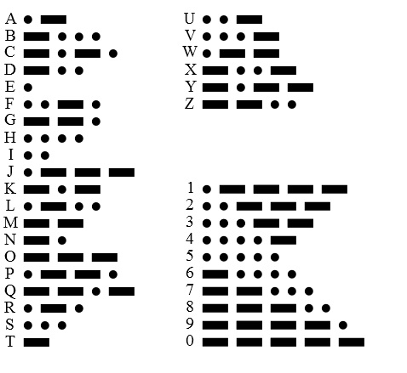(1)

Now each dot (the round circle) lasts for 1 second. So the light bulb will only transmit a beam for 1 second and a line will transmit for 3 seconds. Now each word in a sentence will be separated by a 4 second pause (meaning no signal will be transmitted) and this will signal that a new word is being transmitted as part of the message. Any other length of time greater than 4 seconds will signify the end of the transmission.

Comparison

Our networks using the following ‘model’ in terms of layers:

|  |  |
| --- | --- |
| Layer | What is it doing? |
| Physical Layer | Data encoding Lines and dots used to send the message via the transmitter |
| Data link Layer | This provides a data link between the transmitter and receiver that in theory error free. |
| Transport Layer | This is where the data is streamed between the transmitter and receiver, which is then passed onto the session layer. |
| Session Layer | This where the received message is then decoding from lines and dots and is this passed onto the presentation layer |
| Presentation Layer s | Shows the intended message |

The OSI MODEL

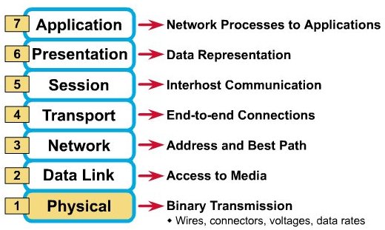(2)

The layers that our model and the OSI model share in common are the Physical, Data Link , Network, Transport , Session, Presentation, Application. The ‘Network’ layer is not shared, as the Morse code system is not being addresses to specific user, it is simply broadcasting the message and will only be picked up if:

* An operator can see the messenger
* There is not ‘address’ or best path that can be given to the data, as it relies on mainly environmental factors such as sufficient weather condition in order to transmit the message without error.

# References

## OSI MODEL: <http://www.gtcc-it.net/billings/osi1.htm>

## Morse code chart: <http://en.wikipedia.org/w/index.php?title=File:International_Morse_Code.svg&page=1>